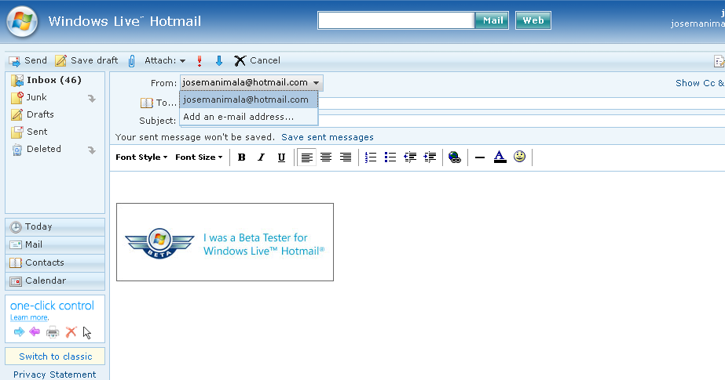

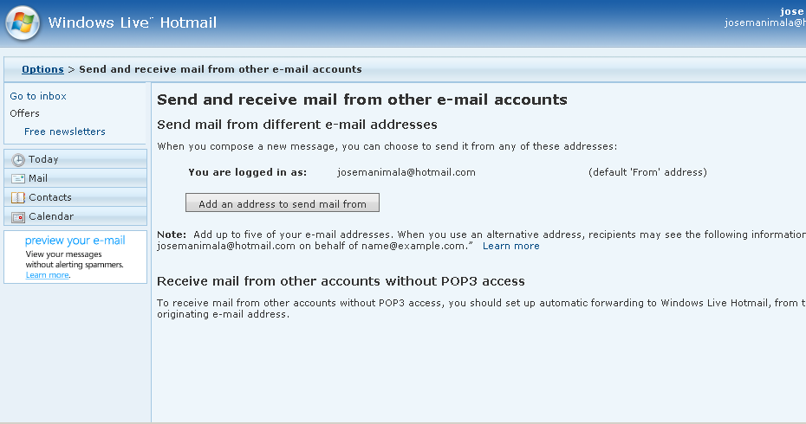

This is exactly what I meant. The new version of live mail supports From and Reply-to addresses. So I guess we can add our email aliases.

